
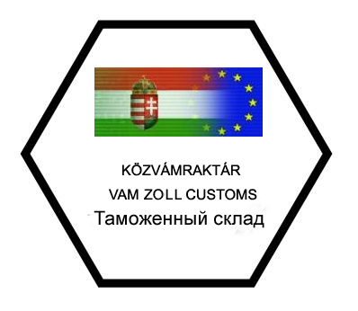
HEXA-COOP SZÖVETKEZET
H-2700 CEGLÉD Külső-Jászberényi út 3.
H-5000 SZOLNOK, Kőrösi út 43.
Tel/Fax:+36-53/310-742, Tel:+36-53/500-168
Mobil: +36-30/6369-300. +36-30/6369-301
E-mail: hexacoop@hexacoop.eu

CONTRACT OF COMMISSION

between
Address:
Tax reg. number: |  | VPID/EORI:

Bank account number (IBAN):
further referred to as Consigner, and Hexa-Coop Szövetkezet Vámraktár Address: H-2700 Cegléd, Külső-Jászberényi út 3, H-5000 Szolnok, Kőrösi út 43., Tax reg. number: 10930692-2-13, EORI: HU0000010180, Bank account number: 10103812-57273348-00000005 further referred to as Consignee.
Consigner commissions consignee with the following: customs administration of procedure, customs warehousing, duty warehousing, simplified export customs procedure, filling in customs forms, customs clearing, subsequent procedures, receipt of certifications, paying registration taxes, registration of EORI/VPID numbers, co-operation in every customs procedure.
Consignee performs a direct (code „2”) representation.
By this present contract, Consigner commissions Consignee on the long run to carry out the loading and unloading tasks at the customs warehouses and duty warehouses operated by Consignee. Consigner does not hand out individual orders to Consignee for unloading or loading for the operation of the customs and duty warehouses.
Consigner hands over Consignee the necessary documents and papers for carrying out customs administrations and other tasks. Consignee works on the basis of the given documents.
Consignee regularly reports to Consigner concerning the tasks carried out. At the same time Consigner gives Consignee its consent to commissioning other customs agencies on the basis of §475 of the Hungarian Civil Code.

Consigner acknowledges that:
- He is entitled to possess free right of disposal over the customs goods cleared by the customs office only after paying the duties and upon the receipt of customs certificate or decision/note sent electronically and signed digitally.
- For probable late balancing of liability to pay Consignee is not responsible.
Consigner gives consent to:
- During a probable customs examination being represented by Consignee.
- Consignee’s receiving the customs decision made instead of Consigner and in his name.

Consigner declares under penalty of perjury that the information, data and the documents attached in order to perform customs clearance are true and real. Consignee undertakes that after carrying out the tasks he hands the documents and certificates belonging to Consigner back.
This present commission is valid for indefinite length of time or until recalled.
The commission can be cancelled by either party without reasoning.
To decide over debated questions both parties designates the District Court of Cegléd (Ceglédi Járásbíróság).
Consignee undertakes the obligation to keep the data and information qualified as confidential by the Consigner. The following, among others, are qualified as business secret: all intellectual products under legal protection being in possession or received during operation of Consigner, information concerning Consigner’s business course, business connections, financing and all information that Consigner qualifies as business secret or it is rightly considerable as a business secret. Consignee is not entitled to reveal information qualified as business secret to any third party, to publish or use in any other way, to use them against the interests of Consigner, exclusively only if Consignee fulfils the requirement of an authority.
Consigner undertakes that he qualifies all information, data and facts received in connection with business operation of Consignee as business secret.

Date: Cegléd, 2014.

……………………………………..… ……………………………………………
Consigner Consignee

